**Industrial Product Development**

**After clicking on it**

**Experiment no 1:** 3 D Printing using FDM

Background procedure simulation limitations Applications

background

(In this the developer has to add the theory of the experiment )

Procedure

(This include aim ,apparatus, procedure,diagram )

Simulation

(Include the diagram with too and fro movement)

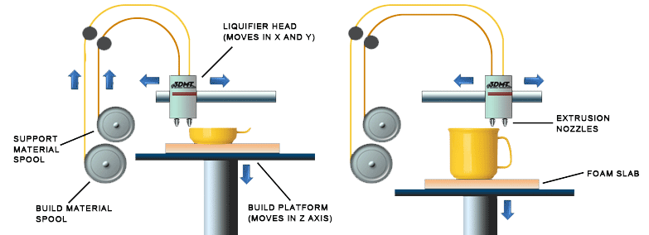

Up and down movement

Circular movement (like rotation of a wheel

Too&fro movement with ijection of melted wire

Limistations :(in this the limistations from the pdf must be entered )

Applications :(in this applications from the pdf must be entered)